**Module 7 - Spring REST using Spring Boot 3**

**Hands on 1**

**Create a Spring Web Project using Maven**  

package com.cognizant.spring_learn;

import org.slf4j.Logger;

import org.slf4j.LoggerFactory;

import org.springframework.boot.SpringApplication;

import org.springframework.boot.autoconfigure.SpringBootApplication;

@SpringBootApplication

public class SpringLearnApplication {

private static final Logger LOGGER = LoggerFactory.getLogger(SpringLearnApplication.class);

public static void main(String[] args) {

SpringApplication.run(SpringLearnApplication.class, args);

LOGGER.info("Application started...");

}

}

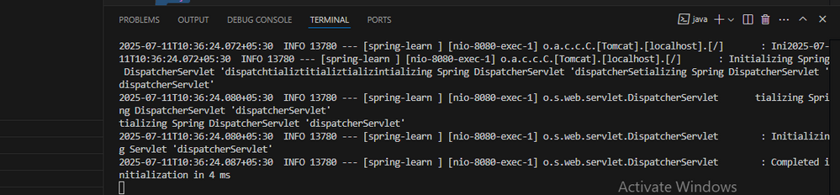

**Hands on 2**

**Spring Core – Load SimpleDateFormat from Spring Configuration XML**    
package com.cognizant.spring_learn;

import java.text.SimpleDateFormat;

import java.util.Date;

import org.slf4j.Logger;

import org.slf4j.LoggerFactory;

import org.springframework.boot.SpringApplication;

import org.springframework.boot.autoconfigure.SpringBootApplication;

import org.springframework.context.ApplicationContext;

import org.springframework.context.support.ClassPathXmlApplicationContext;

@SpringBootApplication

public class SpringLearnApplication {

private static final Logger LOGGER = LoggerFactory.getLogger(SpringLearnApplication.class);

public static void main(String[] args) {

SpringApplication.run(SpringLearnApplication.class, args);

LOGGER.info("Application started...");

displayDate();

}

public static void displayDate() {

LOGGER.info("START");

ApplicationContext context = new ClassPathXmlApplicationContext("date-format.xml");

SimpleDateFormat format = context.getBean("dateFormat", SimpleDateFormat.class);

try {

Date date = format.parse("31/12/2018");

LOGGER.debug("Parsed Date: {}", date.toString());

} catch (Exception e) {

LOGGER.error("Error parsing date", e);

}

LOGGER.info("END");

}

}

<?xml version="1.0" encoding="UTF-8"?>

<beans xmlns="http://www.springframework.org/schema/beans"

xmlns:xsi="http://www.w3.org/2001/XMLSchema-instance"

xsi:schemaLocation="http://www.springframework.org/schema/beans

https://www.springframework.org/schema/beans/spring-beans.xsd">

<bean id="dateFormat" class="java.text.SimpleDateFormat">

<constructor-arg value="dd/MM/yyyy" />

</bean>

</beans>

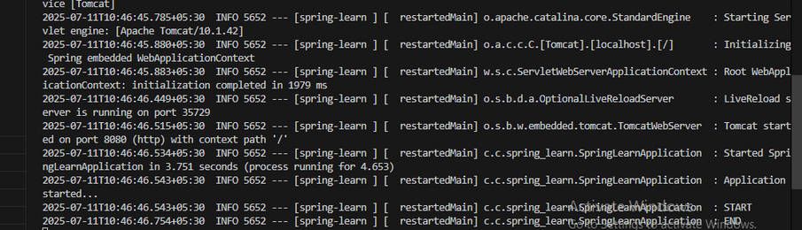

**Hands on 3**

**Spring Core - Incorporate Logging**

package com.cognizant.spring_learn;

import java.text.SimpleDateFormat;

import java.util.Date;

import org.slf4j.Logger;

import org.slf4j.LoggerFactory;

import org.springframework.boot.SpringApplication;

import org.springframework.boot.autoconfigure.SpringBootApplication;

import org.springframework.context.ApplicationContext;

import org.springframework.context.support.ClassPathXmlApplicationContext;

@SpringBootApplication

public class SpringLearnApplication {

private static final Logger LOGGER = LoggerFactory.getLogger(SpringLearnApplication.class);

public static void main(String[] args) {

SpringApplication.run(SpringLearnApplication.class, args);

LOGGER.info("Application started...");

displayDate(); // Call the method here

}

public static void displayDate() {

LOGGER.info("START");

ApplicationContext context = new ClassPathXmlApplicationContext("date-format.xml");

SimpleDateFormat format = context.getBean("dateFormat", SimpleDateFormat.class);

try {

// Parse the date

Date date = format.parse("31/12/2018");

LOGGER.debug("Parsed Date: {}", date.toString());

} catch (Exception e) {

LOGGER.error("Error parsing date", e);

}

LOGGER.info("END");

}

}

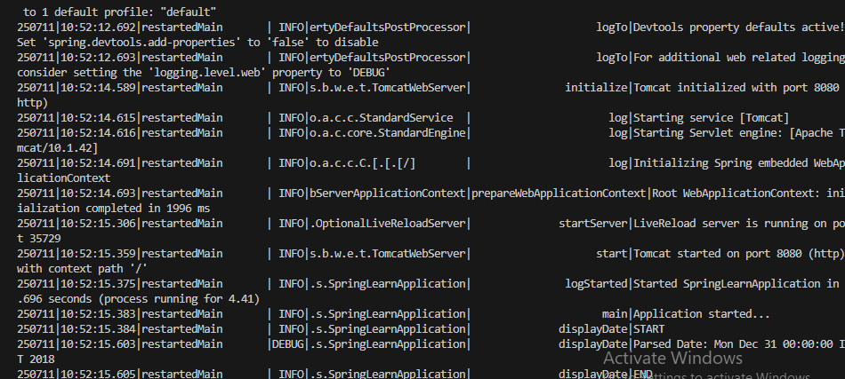

**Hands on 4**

**Spring Core – Load Country from Spring Configuration XML**    
package com.cognizant.spring_learn;

import org.slf4j.Logger;

import org.slf4j.LoggerFactory;

public class Country {

private static final Logger LOGGER = LoggerFactory.getLogger(Country.class);

private String code;

private String name;

public Country() {

LOGGER.debug("Inside Country Constructor.");

}

public String getCode() {

LOGGER.debug("Inside getCode()");

return code;

}

public void setCode(String code) {

LOGGER.debug("Inside setCode()");

this.code = code;

}

public String getName() {

LOGGER.debug("Inside getName()");

return name;

}

public void setName(String name) {

LOGGER.debug("Inside setName()");

this.name = name;

}

@Override

public String toString() {

return "Country [code=" + code + ", name=" + name + "]";

}

}

package com.cognizant.spring_learn;

import java.text.SimpleDateFormat;

import java.util.Date;

import org.slf4j.Logger;

import org.slf4j.LoggerFactory;

import org.springframework.boot.SpringApplication;

import org.springframework.boot.autoconfigure.SpringBootApplication;

import org.springframework.context.ApplicationContext;

import org.springframework.context.support.ClassPathXmlApplicationContext;

@SpringBootApplication

public class SpringLearnApplication {

private static final Logger LOGGER = LoggerFactory.getLogger(SpringLearnApplication.class);

public static void main(String[] args) {

SpringApplication.run(SpringLearnApplication.class, args);

LOGGER.info("Application started...");

displayDate(); // from Hands-on 2

displayCountry(); // Hands-on 4

}

public static void displayDate() {

LOGGER.info("START");

ApplicationContext context = new ClassPathXmlApplicationContext("date-format.xml");

SimpleDateFormat format = context.getBean("dateFormat", SimpleDateFormat.class);

try {

Date date = format.parse("31/12/2018");

LOGGER.debug("Parsed Date: {}", date.toString());

} catch (Exception e) {

LOGGER.error("Error parsing date", e);

}

LOGGER.info("END");

}

public static void displayCountry() {

LOGGER.info("START");

ApplicationContext context = new ClassPathXmlApplicationContext("country.xml");

Country country = context.getBean("country", Country.class);

LOGGER.debug("Country : {}", country.toString());

LOGGER.info("END");

}

}

<?xml version="1.0" encoding="UTF-8"?>

<beans xmlns="http://www.springframework.org/schema/beans"

xmlns:xsi="http://www.w3.org/2001/XMLSchema-instance"

xsi:schemaLocation="http://www.springframework.org/schema/beans

https://www.springframework.org/schema/beans/spring-beans.xsd">

<bean id="country" class="com.cognizant.spring_learn.Country">

<property name="code" value="IN" />

<property name="name" value="India" />

</bean>

</beans>

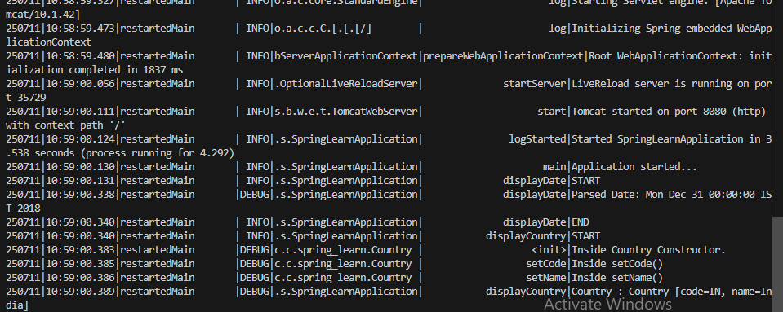

**Hands on 5**

**Spring Core – Demonstration of Singleton Scope and Prototype Scope**    
<?xml version="1.0" encoding="UTF-8"?>

<beans xmlns="http://www.springframework.org/schema/beans"

xmlns:xsi="http://www.w3.org/2001/XMLSchema-instance"

xsi:schemaLocation="http://www.springframework.org/schema/beans

https://www.springframework.org/schema/beans/spring-beans.xsd">

<bean id="country" class="com.cognizant.spring_learn.Country" scope="prototype">

<property name="code" value="IN" />

<property name="name" value="India" />

</bean>

</beans>

package com.cognizant.spring_learn;

import org.slf4j.Logger;

import org.slf4j.LoggerFactory;

public class Country {

private static final Logger LOGGER = LoggerFactory.getLogger(Country.class);

private String code;

private String name;

public Country() {

LOGGER.debug("Inside Country Constructor.");

}

public String getCode() {

LOGGER.debug("Inside getCode()");

return code;

}

public void setCode(String code) {

LOGGER.debug("Inside setCode()");

this.code = code;

}

public String getName() {

LOGGER.debug("Inside getName()");

return name;

}

public void setName(String name) {

LOGGER.debug("Inside setName()");

this.name = name;

}

@Override

public String toString() {

return "Country [code=" + code + ", name=" + name + "]";

}

}

package com.cognizant.spring_learn;

import java.text.SimpleDateFormat;

import java.util.Date;

import org.slf4j.Logger;

import org.slf4j.LoggerFactory;

import org.springframework.boot.SpringApplication;

import org.springframework.boot.autoconfigure.SpringBootApplication;

import org.springframework.context.ApplicationContext;

import org.springframework.context.support.ClassPathXmlApplicationContext;

@SpringBootApplication

public class SpringLearnApplication {

private static final Logger LOGGER = LoggerFactory.getLogger(SpringLearnApplication.class);

public static void main(String[] args) {

SpringApplication.run(SpringLearnApplication.class, args);

LOGGER.info("Application started...");

displayDate(); // Hands-on 2

displayCountry(); // Hands-on 4 & 5

}

public static void displayDate() {

LOGGER.info("START");

ApplicationContext context = new ClassPathXmlApplicationContext("date-format.xml");

SimpleDateFormat format = context.getBean("dateFormat", SimpleDateFormat.class);

try {

Date date = format.parse("31/12/2018");

LOGGER.debug("Parsed Date: {}", date.toString());

} catch (Exception e) {

LOGGER.error("Error parsing date", e);

}

LOGGER.info("END");

}

public static void displayCountry() {

LOGGER.info("START");

ApplicationContext context = new ClassPathXmlApplicationContext("country.xml");

Country country1 = context.getBean("country", Country.class);

Country country2 = context.getBean("country", Country.class); // Fetch again

LOGGER.debug("Country 1 : {}", country1.toString());

LOGGER.debug("Country 2 : {}", country2.toString());

LOGGER.info("END");

}

}

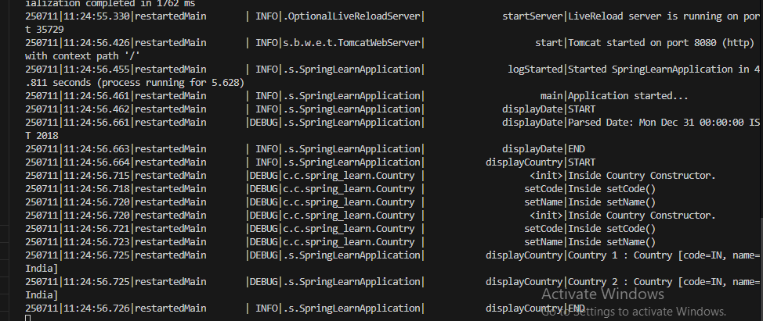

**Hands on 6**

**Spring Core – Load list of countries from Spring Configuration XML**    
package com.cognizant.spring_learn;

import org.slf4j.Logger;

import org.slf4j.LoggerFactory;

public class Country {

private static final Logger LOGGER = LoggerFactory.getLogger(Country.class);

private String code;

private String name;

public Country() {

LOGGER.debug("Inside Country Constructor.");

}

public String getCode() {

LOGGER.debug("Inside getCode()");

return code;

}

public void setCode(String code) {

LOGGER.debug("Inside setCode()");

this.code = code;

}

public String getName() {

LOGGER.debug("Inside getName()");

return name;

}

public void setName(String name) {

LOGGER.debug("Inside setName()");

this.name = name;

}

@Override

public String toString() {

return "Country [code=" + code + ", name=" + name + "]";

}

}

package com.cognizant.spring_learn;

import java.text.SimpleDateFormat;

import java.util.Date;

import java.util.List;

import org.slf4j.Logger;

import org.slf4j.LoggerFactory;

import org.springframework.boot.SpringApplication;

import org.springframework.boot.autoconfigure.SpringBootApplication;

import org.springframework.context.ApplicationContext;

import org.springframework.context.support.ClassPathXmlApplicationContext;

@SpringBootApplication

public class SpringLearnApplication {

private static final Logger LOGGER = LoggerFactory.getLogger(SpringLearnApplication.class);

public static void main(String[] args) {

SpringApplication.run(SpringLearnApplication.class, args);

LOGGER.info("Application started...");

displayDate(); // Hands-on 2

displayCountries(); // Hands-on 4 & 5

}

public static void displayDate() {

LOGGER.info("START");

ApplicationContext context = new ClassPathXmlApplicationContext("date-format.xml");

SimpleDateFormat format = context.getBean("dateFormat", SimpleDateFormat.class);

try {

Date date = format.parse("31/12/2018");

LOGGER.debug("Parsed Date: {}", date.toString());

} catch (Exception e) {

LOGGER.error("Error parsing date", e);

}

LOGGER.info("END");

}

@SuppressWarnings("unchecked")

public static void displayCountries() {

LOGGER.info("START");

ApplicationContext context = new ClassPathXmlApplicationContext("country.xml");

List<Country> countryList = (List<Country>) context.getBean("countryList");

for (Country country : countryList) {

LOGGER.debug("Country: {}", country.toString());

}

LOGGER.info("END");

}

}

<?xml version="1.0" encoding="UTF-8"?>

<beans xmlns="http://www.springframework.org/schema/beans"

xmlns:xsi="http://www.w3.org/2001/XMLSchema-instance"

xsi:schemaLocation="http://www.springframework.org/schema/beans

https://www.springframework.org/schema/beans/spring-beans.xsd">

<!-- Individual country beans -->

<bean id="in" class="com.cognizant.spring_learn.Country">

<property name="code" value="IN" />

<property name="name" value="India" />

</bean>

<bean id="us" class="com.cognizant.spring_learn.Country">

<property name="code" value="US" />

<property name="name" value="United States" />

</bean>

<bean id="de" class="com.cognizant.spring_learn.Country">

<property name="code" value="DE" />

<property name="name" value="Germany" />

</bean>

<bean id="jp" class="com.cognizant.spring_learn.Country">

<property name="code" value="JP" />

<property name="name" value="Japan" />

</bean>

<!-- List of all countries -->

<bean id="countryList" class="java.util.ArrayList">

<constructor-arg>

<list>

<ref bean="in" />

<ref bean="us" />

<ref bean="de" />

<ref bean="jp" />

</list>

</constructor-arg>

</bean>

</beans>

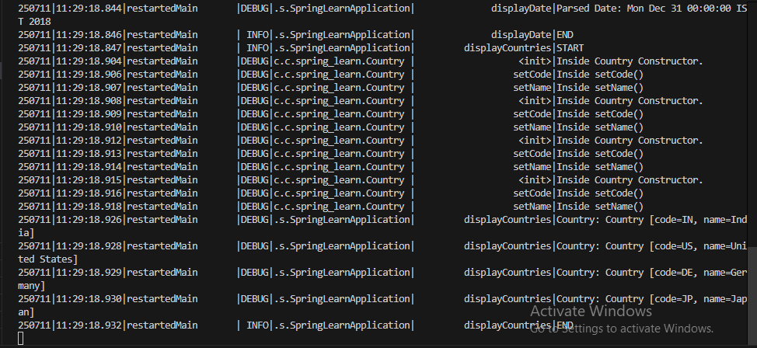

**Exercise 2**

**HTTP Request Response**    
package com.cognizant.spring_learn.controller;

import org.slf4j.Logger;

import org.slf4j.LoggerFactory;

import org.springframework.web.bind.annotation.GetMapping;

import org.springframework.web.bind.annotation.RestController;

@RestController

public class HelloController {

private static final Logger LOGGER = LoggerFactory.getLogger(HelloController.class);

@GetMapping("/hello")

public String sayHello() {

LOGGER.info("START");

String message = "Hello World!!";

LOGGER.info("END");

return message;

}

}

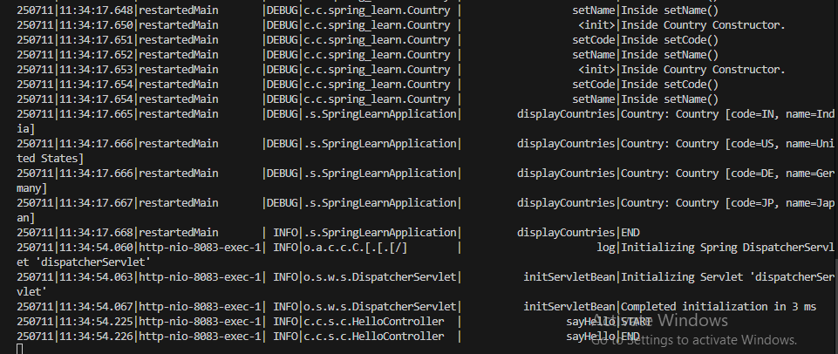

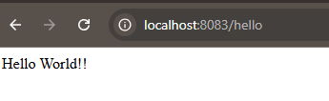

**REST - Country Web Service**    
   
package com.cognizant.spring_learn.controller;

import org.slf4j.Logger;

import org.slf4j.LoggerFactory;

import org.springframework.context.ApplicationContext;

import org.springframework.context.support.ClassPathXmlApplicationContext;

import org.springframework.web.bind.annotation.RequestMapping;

import org.springframework.web.bind.annotation.RestController;

import com.cognizant.spring_learn.Country;

@RestController

public class CountryController {

private static final Logger LOGGER = LoggerFactory.getLogger(CountryController.class);

@RequestMapping("/country")

public Country getCountryIndia() {

LOGGER.info("START");

ApplicationContext context = new ClassPathXmlApplicationContext("country.xml");

Country country = (Country) context.getBean("in");

LOGGER.info("END");

return country;

}

}

<?xml version="1.0" encoding="UTF-8"?>

<beans xmlns="http://www.springframework.org/schema/beans"

xmlns:xsi="http://www.w3.org/2001/XMLSchema-instance"

xsi:schemaLocation="http://www.springframework.org/schema/beans

https://www.springframework.org/schema/beans/spring-beans.xsd">

<!-- Individual country beans -->

<bean id="in" class="com.cognizant.spring_learn.Country">

<property name="code" value="IN" />

<property name="name" value="India" />

</bean>

<bean id="us" class="com.cognizant.spring_learn.Country">

<property name="code" value="US" />

<property name="name" value="United States" />

</bean>

<bean id="de" class="com.cognizant.spring_learn.Country">

<property name="code" value="DE" />

<property name="name" value="Germany" />

</bean>

<bean id="jp" class="com.cognizant.spring_learn.Country">

<property name="code" value="JP" />

<property name="name" value="Japan" />

</bean>

<!-- List of all countries -->

<bean id="countryList" class="java.util.ArrayList">

<constructor-arg>

<list>

<ref bean="in" />

<ref bean="us" />

<ref bean="de" />

<ref bean="jp" />

</list>

</constructor-arg>

</bean>

</beans>

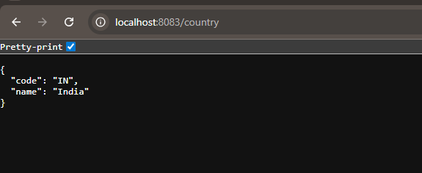

**REST - Get all countries**    
package com.cognizant.spring_learn.controller;

import java.util.List;

import org.slf4j.Logger;

import org.slf4j.LoggerFactory;

import org.springframework.context.ApplicationContext;

import org.springframework.context.support.ClassPathXmlApplicationContext;

import org.springframework.web.bind.annotation.GetMapping;

import org.springframework.web.bind.annotation.RequestMapping;

import org.springframework.web.bind.annotation.RestController;

import com.cognizant.spring_learn.Country;

@RestController

public class CountryController {

private static final Logger LOGGER = LoggerFactory.getLogger(CountryController.class);

@RequestMapping("/country")

public Country getCountryIndia() {

LOGGER.info("START");

ApplicationContext context = new ClassPathXmlApplicationContext("country.xml");

Country country = (Country) context.getBean("in");

LOGGER.info("END");

return country;

}

@GetMapping("/countries")

public List<Country> getAllCountries() {

LOGGER.info("START");

ApplicationContext context = new ClassPathXmlApplicationContext("country.xml");

List<Country> countryList = context.getBean("countryList", List.class);

LOGGER.info("END");

return countryList;

}

}

<?xml version="1.0" encoding="UTF-8"?>

<beans xmlns="http://www.springframework.org/schema/beans"

xmlns:xsi="http://www.w3.org/2001/XMLSchema-instance"

xsi:schemaLocation="http://www.springframework.org/schema/beans

https://www.springframework.org/schema/beans/spring-beans.xsd">

<bean id="in" class="com.cognizant.spring_learn.Country">

<property name="code" value="IN"/>

<property name="name" value="India"/>

</bean>

<bean id="us" class="com.cognizant.spring_learn.Country">

<property name="code" value="US"/>

<property name="name" value="United States"/>

</bean>

<bean id="jp" class="com.cognizant.spring_learn.Country">

<property name="code" value="JP"/>

<property name="name" value="Japan"/>

</bean>

<bean id="de" class="com.cognizant.spring_learn.Country">

<property name="code" value="DE"/>

<property name="name" value="Germany"/>

</bean>

<bean id="countryList" class="java.util.ArrayList">

<constructor-arg>

<list>

<ref bean="in"/>

<ref bean="us"/>

<ref bean="jp"/>

<ref bean="de"/>

</list>

</constructor-arg>

</bean>

</beans>

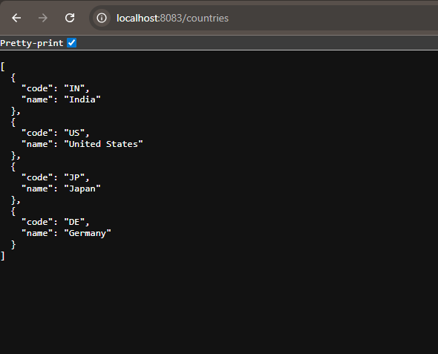

**REST - Get country based on country code**    
package com.cognizant.spring_learn.controller;

import com.cognizant.spring_learn.Country;

import com.cognizant.spring_learn.exception.CountryNotFoundException;

import com.cognizant.spring_learn.service.CountryService;

import org.slf4j.Logger;

import org.slf4j.LoggerFactory;

import org.springframework.beans.factory.annotation.Autowired;

import org.springframework.context.ApplicationContext;

import org.springframework.context.support.ClassPathXmlApplicationContext;

import org.springframework.web.bind.annotation.*;

import java.util.List;

@RestController

public class CountryController {

private static final Logger LOGGER = LoggerFactory.getLogger(CountryController.class);

@Autowired

private CountryService countryService;

@RequestMapping("/country")

public Country getCountryIndia() {

LOGGER.info("START");

ApplicationContext context = new ClassPathXmlApplicationContext("country.xml");

Country country = (Country) context.getBean("in");

LOGGER.info("END");

return country;

}

@GetMapping("/countries")

public List<Country> getAllCountries() {

LOGGER.info("START");

ApplicationContext context = new ClassPathXmlApplicationContext("country.xml");

List<Country> countryList = context.getBean("countryList", List.class);

LOGGER.info("END");

return countryList;

}

@GetMapping("/countries/{code}")

public Country getCountry(@PathVariable String code) throws CountryNotFoundException {

LOGGER.info("START");

Country country = countryService.getCountry(code);

LOGGER.info("END");

return country;

}

}

package com.cognizant.spring_learn.exception;

public class CountryNotFoundException extends Exception {

public CountryNotFoundException(String message) {

super(message);

}

}

package com.cognizant.spring_learn.service;

import com.cognizant.spring_learn.Country;

import com.cognizant.spring_learn.exception.CountryNotFoundException;

import org.springframework.context.ApplicationContext;

import org.springframework.context.support.ClassPathXmlApplicationContext;

import org.springframework.stereotype.Service;

import java.util.List;

@Service

public class CountryService {

public Country getCountry(String code) throws CountryNotFoundException {

ApplicationContext context = new ClassPathXmlApplicationContext("country.xml");

List<Country> countryList = context.getBean("countryList", List.class);

// Lambda to find matching country

return countryList.stream()

.filter(country -> country.getCode().equalsIgnoreCase(code))

.findFirst()

.orElseThrow(() -> new CountryNotFoundException("Country not found with code: " + code));

}

}

<?xml version="1.0" encoding="UTF-8"?>

<beans xmlns="http://www.springframework.org/schema/beans"

xmlns:xsi="http://www.w3.org/2001/XMLSchema-instance"

xsi:schemaLocation="http://www.springframework.org/schema/beans

https://www.springframework.org/schema/beans/spring-beans.xsd">

<bean id="in" class="com.cognizant.spring_learn.Country">

<property name="code" value="IN"/>

<property name="name" value="India"/>

</bean>

<bean id="us" class="com.cognizant.spring_learn.Country">

<property name="code" value="US"/>

<property name="name" value="United States"/>

</bean>

<bean id="jp" class="com.cognizant.spring_learn.Country">

<property name="code" value="JP"/>

<property name="name" value="Japan"/>

</bean>

<bean id="de" class="com.cognizant.spring_learn.Country">

<property name="code" value="DE"/>

<property name="name" value="Germany"/>

</bean>

<bean id="countryList" class="java.util.ArrayList">

<constructor-arg>

<list>

<ref bean="in"/>

<ref bean="us"/>

<ref bean="jp"/>

<ref bean="de"/>

</list>

</constructor-arg>

</bean>

</beans>

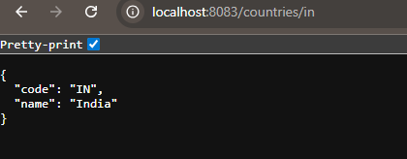

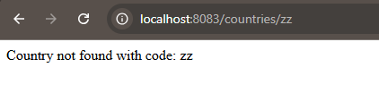

**REST - Get country exceptional scenario**    
package com.cognizant.spring_learn.exception;

public class CountryNotFoundException extends Exception {

public CountryNotFoundException(String message) {

super(message);

}

}

package com.cognizant.spring_learn.service;

import com.cognizant.spring_learn.Country;

import com.cognizant.spring_learn.service.exception.CountryNotFoundException;

import org.springframework.context.ApplicationContext;

import org.springframework.context.support.ClassPathXmlApplicationContext;

import org.springframework.stereotype.Service;

import java.util.List;

@Service

public class CountryService {

public Country getCountry(String code) throws CountryNotFoundException {

ApplicationContext context = new ClassPathXmlApplicationContext("country.xml");

List<Country> countryList = context.getBean("countryList", List.class);

return countryList.stream()

.filter(c -> c.getCode().equalsIgnoreCase(code))

.findFirst()

.orElseThrow(() -> new CountryNotFoundException("Country not found"));

}

}

package com.cognizant.spring_learn.controller;

import com.cognizant.spring_learn.Country;

import com.cognizant.spring_learn.service.CountryService;

import com.cognizant.spring_learn.service.exception.CountryNotFoundException;

import org.slf4j.Logger;

import org.slf4j.LoggerFactory;

import org.springframework.beans.factory.annotation.Autowired;

import org.springframework.context.ApplicationContext;

import org.springframework.context.support.ClassPathXmlApplicationContext;

import org.springframework.web.bind.annotation.*;

import java.util.List;

@RestController

public class CountryController {

private static final Logger LOGGER = LoggerFactory.getLogger(CountryController.class);

@Autowired

private CountryService countryService;

@RequestMapping("/country")

public Country getCountryIndia() {

LOGGER.info("START");

ApplicationContext context = new ClassPathXmlApplicationContext("country.xml");

Country country = (Country) context.getBean("in");

LOGGER.info("END");

return country;

}

@GetMapping("/countries")

public List<Country> getAllCountries() {

LOGGER.info("START");

ApplicationContext context = new ClassPathXmlApplicationContext("country.xml");

List<Country> countryList = context.getBean("countryList", List.class);

LOGGER.info("END");

return countryList;

}

@GetMapping("/countries/{code}")

public Country getCountry(@PathVariable String code) throws CountryNotFoundException {

LOGGER.info("START");

Country country = countryService.getCountry(code);

LOGGER.info("END");

return country;

}

}

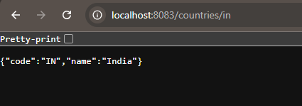

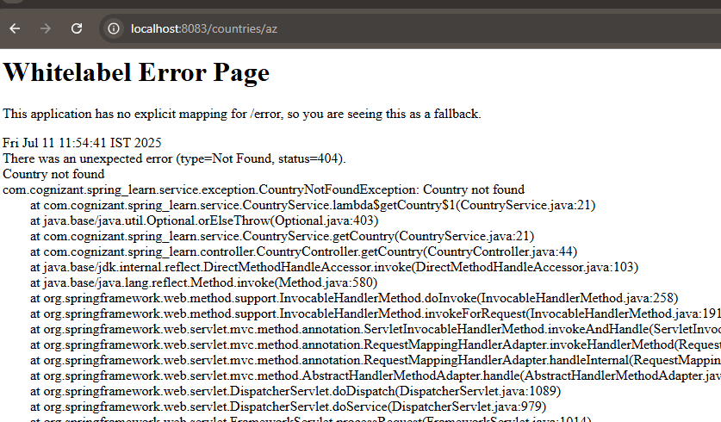

**MockMVC - Test get country service**  